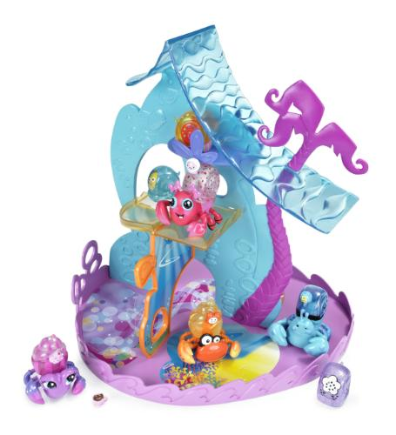
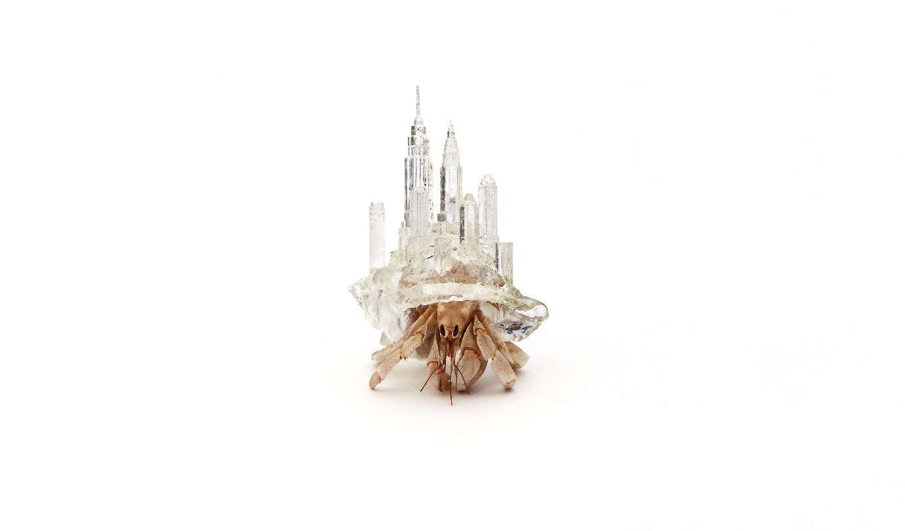
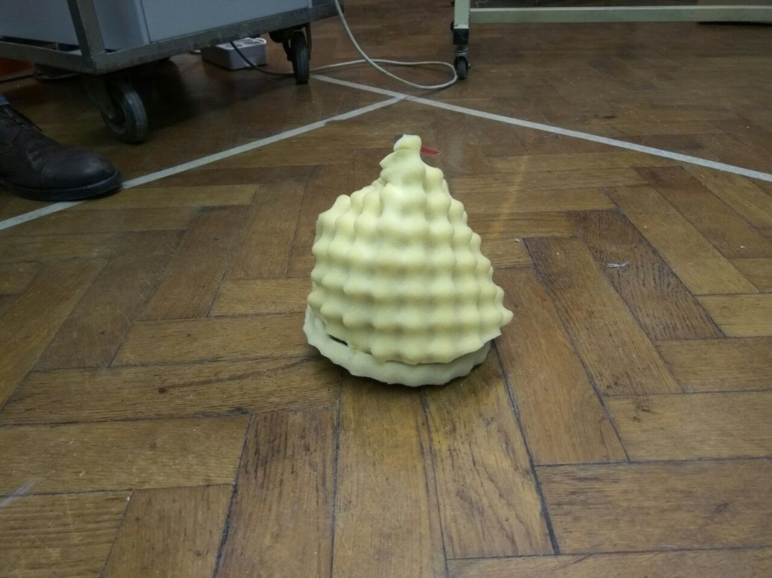
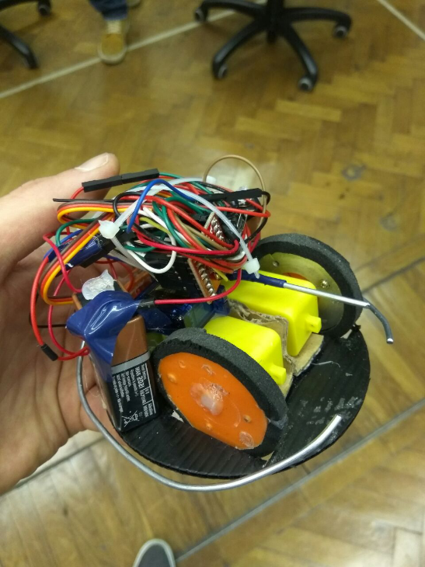
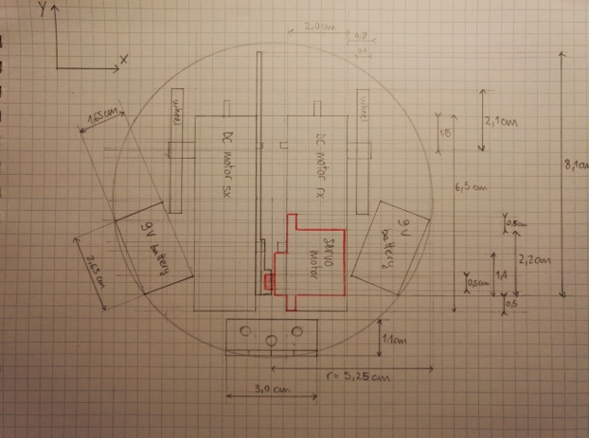
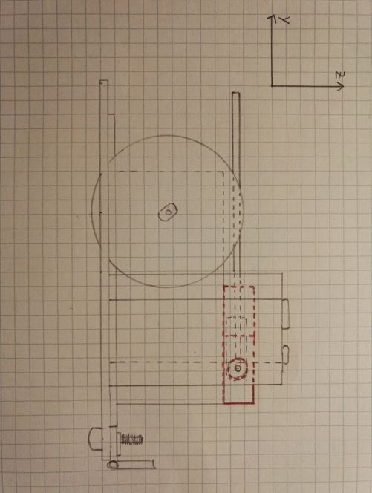

Interdisciplinary course of
Design and Robotics
5° edition, 2017

Professors:
Andrea Bonarini, DEIB department, Politecnico di Milano
Maximiliano Romero , DPAC department, Università IUAV, Venezia

Tutors:
Andrea Brivio, Yael Bendit,

Students:
Moreno Sardella, school of Computer Science and Engineering
Dimitar Anastasovski, school of Computer Science and Engineering
Lorenzo Vignati, school of Biomedical Engineering
Paolo Ritter, school of Biomedical Engineering
Luca Fochetta, school of Computer Science and Engineering

Index

Index 2
Abstract 3
Description 3
Research 3
State of the Art 3
Concept 4
Inspiration 4
Representation 4
<- On the left there is a photo of the mechanical backend of the robot 4
Development 4
Interaction 4
Shape 5
Mechanics 5
Electronics 5
Informatics 5
Conclusions 5
Bibliography 6
Annex 7
Electronics 7
Informatics 7

Abstract
To write at the end, wHEN THE REPORT is finished, describe in short what the reader will read in this article

Description
The purpose of the project is to build an autonomous robot able to interact with people in order to promote a restaurant. Our idea is to build multiple robots with the appearance of hermit crabs that will be able to understand when a person is approaching them and go hide (under their shells). Then they will start slowly to come out from the shell and start to do some movements and attract attention with sound and light. For this prototype, we built an hermit crab able to move around and lift his shell without any remote control or external alimentation.

Research

State of the Art
The state of the art are two different projects, both much different from ours, but still for some aspects similar.
The first one is made by Cepia and is called Xia Xia. It is made for kids and the main attraction are the four little hermit crabs with interchangeable shells that can move around autonomously (but without sensors and steering mechanisms they can only move straight forward and backward). What we take from this project is the presence multiple little robots, but what will distinguish our work is the presence of many sensors and a much more complicated algorithm that will allow real interaction with both the other crabs and the people.
https://www.youtube.com/watch?v=46KlwGfh8VM
The second project is a more complicated robot, that like ours can go around without getting stuck into obstacles, but lacks the aesthetic side and the functions that will allow our robot to interact not only with the environment, but also with people.
https://www.youtube.com/watch?v=gbPtuy5Ew8Y

Concept

Inspiration
The inspiration arrived from an interesting project made by japanese artist, Aki Inomata. She 3D printed shells shaped externally as landscapes of important cities (like New York for example) and internally as a natural shelter for the crabs (after studying the structure with micro CT scans. The meaning of all this is to raise awareness of the problem that people causes to the crab populations by scavenging seashells by the sea.

Representation

<- On the left there is a photo of the mechanical backend of the robot
On the right ->
our hermit crab robot prototype shows his final aspect

Development

Interaction
For this preliminary project our attention was focused on the creation of a robot that besides being able to show his main functions, could give a first demonstration of how small we want it to be. For this reason most of our effort was spent fitting all the needed components in a relatively small ‘shell’ in the most efficient way and making it so it could work without external sources of power.

Shape
The shape of the robot is the one of a hermit crab, with a big conic shell. It was made with two wheels at base in order to make it move.

Mechanics
We used two DC motors controlled by the microprocessor trough a Sparkfun motorDriver and a servomotor to open and close the shell. The servo is posed on the skeleton of the shell.

Electronics
We used Sparkfun Dual Tb6612FNG as motor driver to control two DC motors. As microcontroller we used an Arduino Nano Atmega AT320p to which we connected the driver and the servomotor. The robot is power supplied trough two alcaline battery at 9 volts.

Informatics
We used the library servo.h to control the servomotor whose job is to lift up and down the shell of the hermit crab. The problem we faced was of mechanical origin: the self-made wheels could not be perfectly symmetric, but we managed to solve it by making one motor go slower than the other one.

Conclusions
We learnt about the difficulty of using a small case without having problems arranging the huge mass of cables and all the mechanical parts and about the big amount of energy and power needed by a system like this, which must never be underestimated.

Bibliography
https://www.arduino.cc/en/Reference/Servo
http://www.aki-inomata.com/works/hermit_sea/

Annex

Electronics
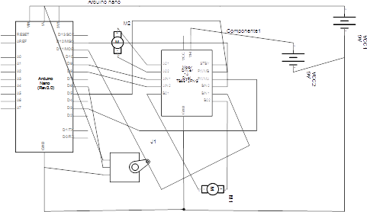

Informatics
Library used:
- servo.h
Link for the code:
https://drive.google.com/open?id=0B0sguQhZEkmZaHdGTWFWbDZnZnM

